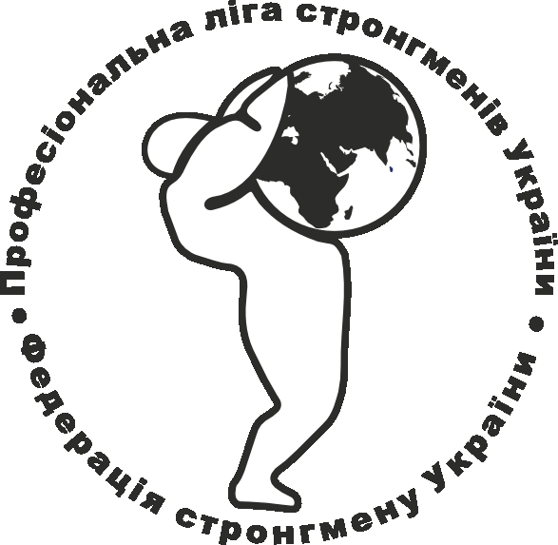
Certificate № 3700 by 16.01.2012р.
ІTN 37935889, JSC CB "PRYVATBANK " (MFO 300711), c/a № 26006052736097
02206 Kyiv, А. Malyshko 31-а of. 35

Regulations
of strongman Championship of Ukraine
(2015 may 23-24, Kyiv)

Dates and place of contest
2015 may 23 Kyiv, park “Friendship of Peoples (Extreme Park)”;
08.00 – 11.00 Mandate Commission, competitors weighing;
10.00 – 10.30 Meeting of judges and team representatives;
11.00 – 11.15 grand opening event;
11.15 – 13.45 performance of competitors in the 95 kg weight category;
14.00 – 15.30 performance of competitors in the 110 kg weight category;
15.45 – 18.15 performance of competitors in the 110+ kg weight category;
18.20 – 18.45 award and closing ceremonies;

Exercises
The 95 kg weight category:
- Super-yoke 320 (250) kg/20m, time limit 60 sec.
- Log-lift 120 (90) kg times, time limit 60 sec.
- Farmer’s walk 2х120 (90) kg/40м, time limit 60 sec.
- Dumbbell 75 (55) kg times, time limit 90 sec.
- Hammer flip 200 (150) kg 5 times, time limit 60 sec.

The 110 kg weight category:
- Super-yoke 360 (280) kg/20м, time limit 60 sec.
- Log-lift 130 (100) kg times, time limit 60 sec.
- Farmer’s walk 2х130 (100) kg/40м, time limit 60 sec.
- Dumbbell 90 (65) kg times, time limit 90 sec.
- Hammer flip 250 (200) kg 5 times, time limit 60 sec.

The 110+ kg weight category:
- Super-yoke 380 (300) kg/20м, time limit 60 sec.
- Log-lift 140 (110) kg times, time limit 60 sec.
- Farmer’s walk 2х140 (110) kg/40м, time limit 60 sec.
- Dumbbell 95 (75) kg times, time limit 90 sec.
- Hammer flip 300 (250) kg 5 times, time limit 60 sec.

In brackets () - shown the weight for amateur athletes. That athlete can declare on one of the scales, but try to perform at the competition is given only once, the athlete can choose only one weight, in the case of an offense result recorded in the protocol as the final! In Scoring weight is more preferred.

2015 may 24 Kyiv, park “Friendship of Peoples (Extreme Park)”;
09.00 – 10.00 Mandate Commission;
10.00 – 10.30 Meeting of judges and team representatives;
11.00 – 11.15 grand opening event;
11.15 – 12.15 Log-lift for maximum;
12.30 – 13.00 Farmer’s walk 170 kg for a distance;
13.00 – 13.45 Dumbbell for maximum;
13.45 – 14.15 Shield 170 kg for a distance;
15.00 – 15.45 Deadlift for maximum;

Competitors, competitors requirements, conditions of competition
1. In the strongman championship of Ukraine athletes under 15 will not participate.
2. The weight category – 95 kg; 110 kg; 110+ kg (men).

Equipping
Shorts for legs and other no limits.

Entry fee – 100 UAH.

Recommended Hotel is «Bratislava» (Kyiv, Malyshko str. 1)

Awarding
1. The first 3 places of each weight category are awarded with cash prizes in the amount - 500 UAH.
2. Athletes who took 1-3 places in their categories are awarded with diplomas of Ukraine’s Derzhmolodsportu and medals of І; ІІ; ІІІ denomination from Strongman Federation of Ukraine; Winners coaches are awarded with diplomas of Ukraine’s Derzhmolodsportu.
3. Athletes who win the first places will be awarded with cups and prizes by competitions sponsors and SFU.
Financing and conditions of participants admission
Travel expenses of participants, trainers (in both directions of travel, subsistence, preservation of wages) are provided by ownself.

Application, registration of competitors
Preliminary applications sent by NO LATER THAN 15 May at the e-mail address: konyushok@ukr.net, 50183@rambler.ru
In previous applications must be specified the name of the command, names of athletes, team address, the number of teams members and weight categories in which the team intends to act, belonging to the sports department or company, all the athletes sports level (including, if any - from other kinds of sport).
All applications must be stamped by territorial executive agency of physical culture and sports!

All participants during weighing before the competition provide for credentials committee passports, command application, certified by a doctor and a responsible person, insurance policies.

For more information:
+38-050-294-70-66 – Konyushok Sergiy - President of the Strongman Federation of Ukraine;
+38-067-722-47-43 – Olga Kovalchuk - SFU general secretary;

