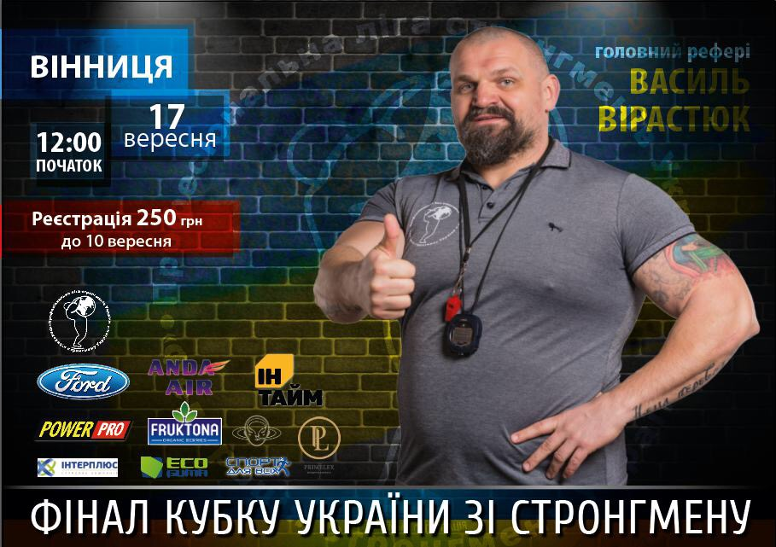

<https://vn.20minut.ua/Sport/naysilnishi-strongmeni-bili-rekordi-i-tyagali-vantazhivku-u-vinnitsi-10638180.html> 1117

<http://other.sport.ua/news/356647> 419

<https://www.youtube.com/watch?v=xi-rDlHbVVU> 135

<https://www.youtube.com/watch?v=-K53BLcKyvE> 58

<https://www.youtube.com/watch?v=aozrR0MlAw0> 91

<http://www.vinnitsa.info/news/do-vinnitsi-na-final-kubku-ukrayini-zi-strongmenu-zyidutsya-ponad-30-sportsmeniv.html> 138

<http://www.myvin.com.ua/ru/news/culture/51219.html> 886

<https://www.youtube.com/watch?time_continue=8&v=ovsZWikIV9Q> 13

<http://www.vin.gov.ua/news/ostanni-novyny/5448-na-final-kubku-ukrainy-zi-stronhmenu-do-vinnytsi-zavitaiut-try-desiatky-naisylnishykh-liudei-krainy>

<https://vinbazar.com/news/kultura-i-sport/u-vinnitsi-proide-final-kubku-ukrayini-zi-strongmenu> 246

<http://noc-vin.org.ua/?p=13511> 11

<http://yspih.com.ua/sport/u-vinnytsi-projshov-final-kubku-ukrayiny-zi-strongmenu> 5

<http://glavcom.ua/vinnytsia/news/yak-virastyuk-u-vinnici-vibirav-naysilnishogo-cholovika-ukrajini-fotoreportazh-438221.html>

<http://vezha.vn.ua/u-vinnytsi-obraly-najsylnishyh-cholovikiv-krayiny-fotoreportazh/>

<http://www.vinnitsa.info/news/yak-u-vinnitsi-ukrayinski-strongmeni-miryayutsya-silami-bogatiriv-sudit-virastyuk-fotoreportazh.html>

<http://www.segodnya.ua/ukraine/v-vinnice-proshel-chempionat-sredi-bogatyrey-1056649.html> 435

<http://vlasno.info/suspilstvo/8/sport/item/19926>